Behaviorist Theory
Behaviorism Assumptions – Behaviorists see psychological disorders as the result of maladaptive learning. They do not assume that sets of symptoms reflect single underlying causes.
Behaviorism assumes that all behavior is learnt from the environment and symptoms are acquired through classical and operant conditioning. Consequently, if a behavior is learned, it can also be unlearned. There are two aspects to behavior therapy.
Functional analysis: the therapist analyses the client’s problem in terms of:
1. Which behaviors are actually the problem
2. Which environmental stimuli trigger the behavior
Treatment: the therapist designs a program to help the client:
1. Unlearn the maladaptive responses
2. Learn more adaptive behaviors (if appropriate)

A. Behavior Therapy (Therapies based on classical conditioning)
Behavior therapies are based on the theory of classical conditioning. The premise is that all behavior is learned; faulty learning (i.e. conditioning) is the cause of abnormal behavior. Therefore the individual has to learn the correct or acceptable behavior. An important feature of behavior therapy is its focus on current problems and behavior, and on attempts to remove behavior the patient finds troublesome. This contrasts greatly with psychodynamic therapy (re: Freud), where the focus is much more on trying to uncover unresolved conflicts from childhood (i.e. the cause of abnormal behavior).
The theory of classical conditioning suggests a response is learned and repeated through immediate association. Behavior therapies based on classical conditioning aim to break the association between stimulus and undesired response (e.g. phobia, additional etc).

Systematic Desensitization
· Based on the idea of incompatible responses
· Aims to substitute the patient’s anxiety response with a relaxation response
This therapy aims to remove the fear response of a phobia, and substitute a relaxation response to the conditional stimulus gradually. This is done by forming a hierarchy of fear, involving the conditioned stimulus (e.g. a spider), that are ranked from least fearful to most fearful.
Thus, for example, a spider phobic might regard one small, stationary spider 5 meters away as only modestly threatening, but a large, rapidly moving spider 1 meter away as highly threatening. The client reaches a state of deep relaxation, and is then asked to imagine (or is confronted by) the least threatening situation in the anxiety hierarchy. The client repeatedly imagines (or is confronted by) this situation until it fails to evoke any anxiety at all, indicating that the therapy has been successful. This process is repeated while working through all of the situations in the anxiety hierarchy until the most anxiety-provoking.
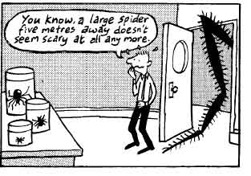
The patient is also given training in relaxation techniques. E.g. control over breathing, muscle detensioning. However, studies have shown that neither relaxation nor hierarchies are necessary, and that the important factor is just exposure to the feared object or situation.
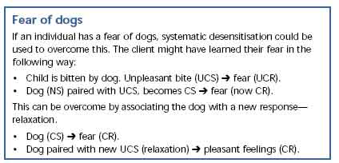
The number of sessions required depends on the severity of the phobia. Usually 4-6 sessions, up to 12 for a severe phobia. The therapy is complete once the agreed therapeutic goals are met (not necessarily when the person’s fears have been completely removed).
Exposure can be done in two ways:
· In vitro – the client imagines exposure to the phobic stimulus
· In vivo – the client is actually exposed to the phobic stimulus

Appropriateness of Systematic Desensitization
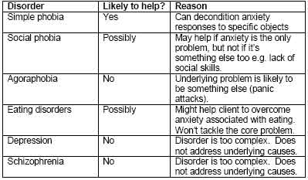
Effectiveness of Systematic Desensitization
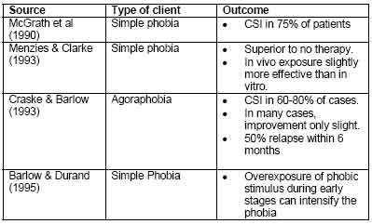
Summary
· SD is highly effective where the problem is learned anxiety of specific objects/situations.
· Functional analysis must be done carefully to avoid overexposing the client and making matters worse.
· SD could help treating some of the additional problems that may accompany anorexia and schizophrenia.
· However, it will not be effective in treating the underlying causes of these disorders.

Aversion Therapy
Aversion therapy is used when there are stimulus situations and associated behavior patterns that are attractive to the client, but which the therapist and the client both regard as undesirable. For example, alcoholics enjoy going to bars and consuming large amounts of alcohol. Aversion therapy involves associating such stimuli and behavior with a very unpleasant unconditioned stimulus, such as an electric shock. The client thus learns to associate the undesirable behavior with the electric shock, and a link is formed between the undesirable behavior and the reflex response to an electric shock.
In the case of alcoholism, what is often done is to require the client to take a sip of alcohol while under the effect of a nausea-inducing drug. Sipping the drink is followed almost at once by vomiting. In future the smell of alcohol produces a memory of vomiting and should stop the patient wanting a drink.
Apart from ethical considerations, there are two other issues relating to the use of aversion therapy. First, it is not very clear how the shocks or drugs have their effects. It may be that they make the previously attractive stimulus (e.g. sight/smell/taste of alcohol) aversive, or it may be that they inhibit (i.e. reduce) the behavior of drinking. Second, there are doubts about the long-term effectiveness of aversion therapy. It can have dramatic effects in the therapist’s office. However, it is often much less effective in the outside world, where no nausea-inducing drug has been taken and it is obvious that no shocks will be given.
Also, relapse rates are very high – the success of the therapy depends of whether the patient can avoid the stimulus they have been conditioned against. Aversion therapy also has many ethical problems.
Implosion Therapy and Flooding
In implosion therapy the subject is asked to imagine the worst possible situation involving the phobia. Whereas in flooding the worse possible situation is actually physically and continuously presented. For example, the client could be put in a room full of spiders. The client is initially flooded or overwhelmed by fear and anxiety. However, the fear typically starts to subside after some time. If the client can be persuaded to remain in the situation for long enough, there is often a marked reduction in fear.
Why is flooding or exposure effective? It teaches the patient that there is no objective basis to his or her fears (e.g., the spiders do not actually cause any bodily harm). In everyday life, the phobic person would avoid those stimuli relevant to the phobia, and so would have no chance to learn this.
Flooding and implosive therapy are considered to be the most successful at treating phobias. They are also cheap (in terms of time and money) to administer, but involve ethical problems of suffering from the therapy. Therefore, this type of therapy would not be suitable for someone with a bad heart or who suffered from nerves etc.
B. Behavior Modification (Therapies based on operant conditioning)
Behavior modification is a set of therapies / techniques based on operant conditioning, i.e. the reinforcement of desired behaviors and ignoring or punishing undesired ones. This is not as simple as it sounds — always reinforcing desired behavior, for example, is basically bribery. The "schedule" of reinforcement is critical. Behavior modification is much used in clinical and educational psychology, particularly with people with learning difficulties. In the conventional learning situation it applies largely to issues of class- and student management, rather than to learning content. It is very relevant to shaping skill performance, however. It applies at the micro-level: student feedback of high marks for good work is only behavior modification in the broadest and weakest sense, whereas attention and praise at the second-by-second level are much more likely to follow its principles.

Therapy cannot be effective unless the behaviors to be changed are understood within a specific context. Therefore, a functional assessment is needed before performing behavior modification. One of the simplest yet effective methods of functional assessment is called the "ABC" approach, where observations are made on Antecedents, Behaviors, and Consequences. In other words, "What comes directly before the behavior?", "What does the behavior look like?", and "What comes directly after the behavior?" Once enough observations are made, the data are analyzed and patterns are identified. If there are consistent antecedents and/or consequences, then an intervention should target them in order to increase or decrease the target behavior.
A simple way of giving positive reinforcement in behavior modification is in providing compliments, approval, encouragement, and affirmation; a ratio of five compliments for every one complaint is generally seen as being the most effective in altering behavior in a desired manner.

Behavior Shaping
This technique works by positively reinforcing successive approximation to the desired behavior step by step. This has found to be an effective technique to needs to be maintained for the person to continue their behavior.
Application
(For example, this can be used to improve the communication skills of an autistic child.)
• The therapist first identifies an activity which the child enjoys, such as playing with a special toy.
• Every time the child looks at the therapist she gives him the toy to play with.
• Eventually the child looks at the therapist in anticipation of the toy but she withholds it until the child reaches for the toy.
• Every time he reaches for the toy, he is given it as the therapist says “please”.
• When reaching has become established, the toy is withheld until the child himself makes a sound as he reaches, he is then given the toy.
• This continues, reinforcing behavior and then withholding reinforcement until a more specific behavior has become established.

Token Economy
This is a type of behavior modification therapy and is only carried out in institutional settings (e.g. hospitals, schools). It is mainly based on the use of positive reinforcement to promote specific behaviors. Although is may involve punishment to extinguish unwanted behaviors. Staff may take away tokens if they wish to punish certain behaviors.
The principle here is that desired behavior is rewarded with tokens which can easily be exchanged form something the individual wants. Tokens act as secondary reinforcers. They have no intrinsic value, but they can be used to obtain things that do (primary reinforcers). Primary reinforcers in a token economy could include:
· Sweets and drinks
· Access to television
· Trips
· Increased freedom within the institution

This has been found to be very effective in managing psychiatric patients. However, the patients can become over reliant on the tokens, making it difficult for them once they leave prisons, hospital etc.
The management of the institution decides:
1. Which specific behaviors they wish to promote
2. Which (if any) specific behaviors they wish to extinguish
Appropriateness of Token Economies
· Token economies do not cure people of psychological disorders
· However, they may reduce some behavioral problems that may accompany psychological disorders
· E.g. aggression, inappropriate social interaction
· They are particularly good for tackling ‘institutionalization’
· People in long-stay care may lose their motivation for everyday self-care behavior (e.g. dressing, washing)
· Token economies can help to restore these behaviors.
Effectiveness of Token Economies
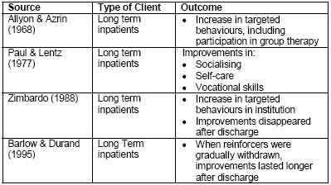
Ethical Issues with Token Economies
Possible problems:
· Dehumanizing – treats people like automata/circus animals.
· Makes clients dependent, not independent.
· Requires patients to be deprived of basic rights.
· Therapeutic goals not set by client.
· Possibly done for the benefit of the institution, not the patients.

Taken from: http://www.simplypsychology.pwp.blueyonder.co.uk/behaviour-therapy.html on 13 March 2009.

